ELEC-3800

Random Signals and Systems

FROM: Jacob Howard

TO: Prof. Stan Reeves

DUE DATE: 4/15/22

Project 5

# **Introduction**

In this project, we ran various simulations in Matlab for testing and observation. We used MatLab functions to find the sample mean and autocorrelation.

# **Exercise 1**

In Step 1, we were asked to find the sample mean of “x”. This was very simple to do in MatLab. The MatLab code and output can be found in *Code 1* below.

|  |
| --- |
| %% Task 1  clc;  clear;  x = [ 0.2117  4.8205  -1.5264  -1.8041  1.1475  -0.1868  -3.8042  -0.8943  6.6410  13.6679  5.2559  7.9250  8.9845  5.9159  5.3183  2.2778  -0.8489  2.4343  4.8345  9.5419  5.7403  2.1826  0.7518  5.3384  4.0681  3.5725  3.5535  3.0961  1.4109  -0.6826  2.1655  -0.7410  -3.6033  -3.0007  -9.7967  -3.8670  0.6420  -1.5249  1.5607  -2.5460  -3.7541  -1.7833  0.1751  3.2569  -1.7481  -1.2783  -1.1751  -1.3888  2.6474  3.0603];  mean1 = mean(x)  Output:  mean1 =  1.5249 |

*Code 1*

# **Exercise 2**

In part 2, we were asked to find R(0.5n) for n = -50<x<50 according to Eq. 6-15. The matlab code can be seen in *Code 2* and the plot can be seen below in *Figure 2.*

|  |
| --- |
| %% Part 2  t = 0.05;  xc = xcorr(x, 50, 'unbiased');  xb = xcorr(x, 50, 'biased');  plot([-50:50]*t, xc) |

*Code 2*

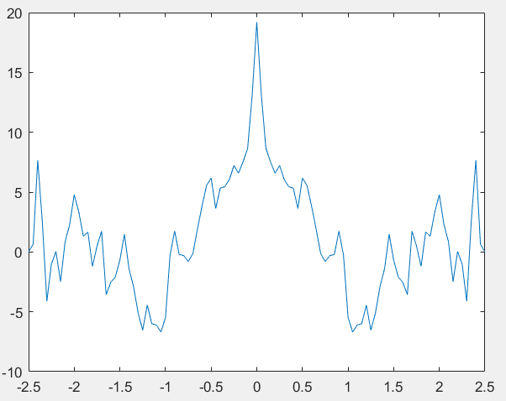

*Figure 2*

# **Exercise 3**

In task 3, we were asked to find R(0.05n) for n = -50,…,50 according to Eq. 6-16. The code can be seen in Code 3 below and the graph can be seen in *Figure 3. Figure 4* shows the graph from parts 2 and 3 in one figure.

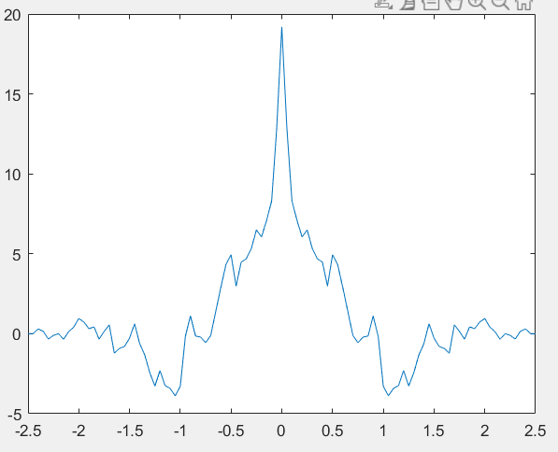

*Figure 3*

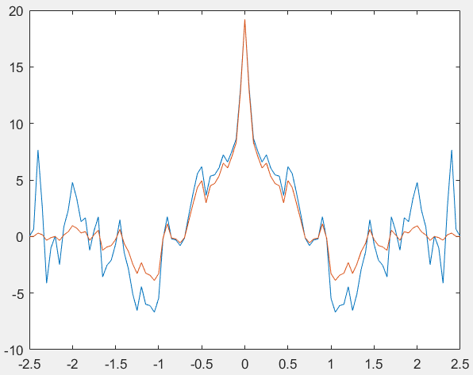

*Figure 4*

|  |
| --- |
| %% Task 1  clc;  clear;  x = [ all values from part 1];  mean1 = mean(x)  %% Part 2  figure(1)  t = 0.05;  xc = xcorr(x, 50, 'unbiased');  xb = xcorr(x, 50, 'biased');  plot([-50:50]*t, xc)  %% Part 3  hold on  plot ([-50:50]*t,xb) |

*Code 2*

# **Exercise 4**

For part 4, we were asked to answer this question:

“Explain why the values in #2 vary so much for large n compared to the same values of n in #3. Are these values in #2 a reliable indicator of the actual autocorrelation? Why or why not?”

Answer: The values differ between biased and unbiased due to the different denominators in their functions. The unbiased autocorrelation function has a larger denominator which causes large variance in the function and unbiased autocorrelation is a reliable indicator due to having a higher mean squared error.

# **Conclusion**

In conclusion, this project was not too difficult. The main thing covered in this project was calculating autocorrelation and comparing functions. After figuring out how to correctly write the functions in Matlab, the project was simple.